The Disposition of a King

## C:\Users\Deliverance\Desktop\Untitled.pngTEXT: **Matthew 27:26-54**

## Introduction

### Disposition

**DEFINITION**: natural mental and emotional outlook or mood; the way in which something is placed or arranged, especially in relation to other things.

**Luke 2:49**—*…* ***I must be about my Father's business****?*

### The King

The greatest man who ever lived is the God-man: JESUS CHRIST! He was Divine and yet human. He demonstrated excellence and leadership in every area of His life—HE IS THE KING. (Matthew 2:2)

### The King’s Men

**Acts 4:13**—*… they took knowledge of them, that* ***they had been with Jesus.***

Successful leaders produce leaders. (Daniel 5:8-9,17; Deut. 28:13,15)

## His Disposition Toward Self

**Matthew 26:38,39; Ephesians 5:25**.

**The commitment of a king is never to himself, but to his God and to his people.**

## His Disposition Toward Sin

Much is said about a person by their disposition toward sin. You Arrive to the Fire with Two Buckets (Fire and Gasoline).

**Matthew 27:45,46**— *…My God, my God, why hast thou forsaken me?*

**Sin is an enemy that effectively divides us from those we love us best.**

## His Disposition Toward God

A.W. Tozer says that people who are crucified with Christ have three distinct marks:

1. they are facing only one direction,

2. they can never turn back, and

3. they no longer have plans of their own.

## His Disposition Toward Others

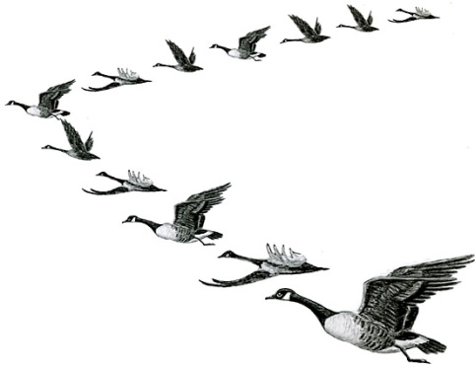**Luke 23:34**—*.. forgive them; …*

**The King understands the greatness of his responsibility and knows how to share the load.**

## Conclusion

**Philippians 2:7,8**— *…* ***he humbled himself****, and became obedient unto death, even the death of the cross.*

**The robe did not make the king, but it is the king that made the robe.**

**Matthew 27:54**—*… Truly this was the Son of God.*

The KING is Committed, Determined, Decided, Resolved, Involved, the Leader, and in his own opinion: **last**.